PERSONNEL SYSTEMS
M&IS44181
Wednesdays 6:15 To 8:45
Telephone: 330.384.4856 (office and voice mail)
E-mail: eckmanr@firstenergycorp.com
Office Hours: Wednesdays: 8:45 (immediately following class) or by appointment
MATERIALS
Text: Rampton, G., Turnbull, I., & Doran, A. (1999). Human Resources Management Systems (2nd ed.). Scarborough, Ontario: Carswell. ISBN: 0176048251

COURSE DESCRIPTION
This course is a comprehensive analysis of human resource information systems (HRIS). The major applications concerning HRIS will be presented, explored, and integrated in order to assist students in understanding how the use of information systems can be used to improve the management of human resources in an organization. Emphasis will be placed on the use of computer applications such as human resource planning, selection, performance appraisal, compensation, benefits administration, and HR Portals. Through lecture and class discussions we shall consider the contributions of these computer applications to improved short- and long-term organizational functioning. Moreover, the course will provide a basis for understanding how the adoption and implementation of an HRIS may assist an organization in attaining its goals.
COURSE OBJECTIVES
The fundamental purpose of this course is to provide the student with an increased understanding of the theory and application of information systems technology as it relates to the field of Human Resources Management.
Following the completion of this course, a student should understand and be able to suggest solutions to human resource-related problems using information systems technology. Additionally, the student should know the attributes of a well-designed human resource information system as well as the impact such a system would have on an organization.
COURSE REQUIREMENTS
Exams
Two exams are scheduled for the semester. All exams will cover text readings, handouts, guest speakers, and lecture material. The format of the exams may include multiple choice, matching, and/or short answer essay questions. Each exam will account for 25% of your final grade.

Group Project:
Your group project will consist of 4 to 5 members, one being designated as the Team Lead. Your team will be responsible for developing an HR Portal for your business. The business creation, concept, and requirements will be developed by your group as you will build a prototype of your portal and show how this portal will link your employees and your organization.
You will present your solution to the board of directors. Your goal is to communicate project scope and receive management approval for project kick off. More information to follow…..

HRIS Knowledge Share
Each student is expected to perform research to develop an HRIS related case, then provide a report of that case in class including a 1 to 2 page overview of their findings. Students are expected to utilize the resources in the book, the library, and the internet for information in relation to their topic. Topics are to be approved by the professor prior to presenting.

Participation:
Students will receive credit for class participation, which will account for 10% of your final grade. Attendance is NOT required for this class. ie.. I will NOT be taking attendance. Each individual will be evaluated on the quality and quantity of her/his participation during class sessions. To receive an acceptable participation grade you must be consistently knowledgeable concerning all assigned readings and you must actively participate in class discussions. This would be difficult to do if you are not in class. AND my tests will encompass much of the information from the book, but 30% will be derived directly from lecture. In other words, if you are not present to learn and understand this information, the you will begin the test with a 70% of the needed material (~Assuming you have read and studied the book~)

GRADES
Grades will be calculated according to performance on the two exams (25% each), Knowledge Share(10%), group project (30%), participation (10%). Final grades will be assigned as follows:
A | B | C | D | F
100 - 90% | 89 – 80% | 79 - 70% | 69 - 60 | <60%

CLASS PROCEDURES
- If my office hours are not convenient for you, please feel free to call for an appointment. Also, the most efficient way to communicate with me is via e-mail. I strongly encourage you to take advantage of the electronic messaging capabilities made available to you by the university!
- Please tell me about any problems you are having while there is still time to do something about them!
- Each student must turn in an original piece of work
- Exams are to be taken at the scheduled time (this also means you need to be on-time for the exam—more than 20 minutes late is a missed exam). If you miss an exam due to a legitimate reason (e.g., illness, death in the immediate family), a make-up exam will be given (you will be required to provide an official university excuse in order to be eligible for a make-up exam). If you do not provide a legitimate excuse, no make-up exam will be granted.
- Reading assignments are expected to be completed prior to class attendance so that you may participate in class discussion. However, we will not discuss every aspect of the assigned chapters or supplemental material. This does not release the student from the responsibility of knowing the material for examination purposes. Conversely, I may include material in class not covered by the text (you are also responsible for this information).
- Attendance at class is expected but will not be monitored. If you miss a class, you are responsible for obtaining lecture notes and other material from another student (please DO NOT ask to borrow my notes).
- Major grammatical or spelling errors on any written work could result in a significant penalty with respect to the grade you receive. Carefully proof your papers for errors (you may even want to have a friend read your work). Use grammar and spell check!
- The best way to reach me is via Email (see email address). I can also be reached via Voice Mail. I will be requesting that each of you provide an email address that you check regularly (daily).
- As I realize that many evening students work full time, I will be providing class time for you to work in your groups. These will be referred to as Group Days and will be assigned according to how well we move through the material throughout the semester
- LATE REGISTRATION: No late registration forms will be signed following the first exam. If you wish to register for the class, you MUST REGISTER BEFORE THE FIRST EXAM—NO EXCEPTIONS!
- Students with Disabilities: In accordance with University policy, if you have a documented disability and require accomodations to obtain equal access in this course, please contact the instructor at the beginning of the semester or when given an assignment for which accomodation is required. Students with disabilities must verify their eligibility through the Office of Student Disability Services (SDS) in the Michael Schwartz Services Center (672-2972).
POLICY ON ACADEMIC DISHONESTY
Students are expected to exercise total academic honesty in the completion of all course requirements. Academic dishonesty includes plagiarism, cheating on examinations, or assisting another student in committing acts of academic dishonesty. The use of academic dishonesty in the completion of this course will result in the appropriate academic and university penalties as found in the Kent State Handbook.
IMPORTANT DATES
1st Class : Wednesday, August 24th
Last day to DROP Saturday, September 11th
Thanksgiving Holiday Wednesday, November 24th (Noon)
Last Class : Wednesday, December 8th
Final Examinations: Monday, December 13th through Sunday, December 19th
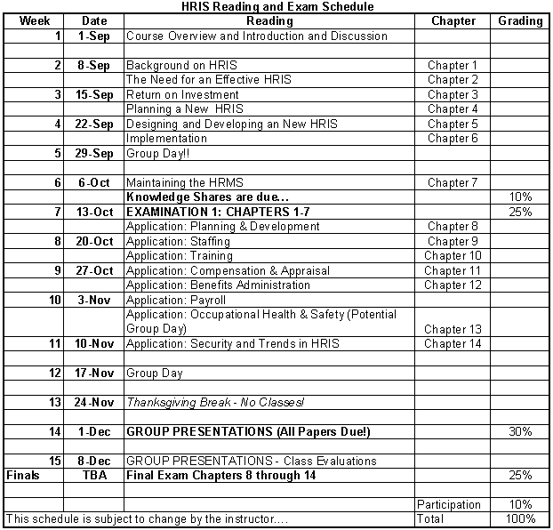
Actual day and location of Final to be announced

